As we lead this effort across Oregon, the Distance Learning for All Guiding Principles will anchor our state in common values and help generate collective action during this time:

Ensure safety and wellness. Students need food, clothing, a safe place to learn and shelter, as well as a sense of care and connection, in order to engage in challenging intellectual work.
- Cultivate connection and relationship. Student connections and relationships with trusted adults promote belonging, which is especially important as learning takes place outside of the school setting.
- Center in equity and efficacy. Prioritize equity in every decision; build on cultural and linguistic assets to inspire learning and promote student efficacy. Consider how decisions and actions attend to racial equity and social justice (Oregon Educator Equity Lens). Consider the assets of students who experience disability.
- Innovate. Iterate through complex change with a spirit of possibility, centering in deep learning, student agency, and culturally sustaining practices.
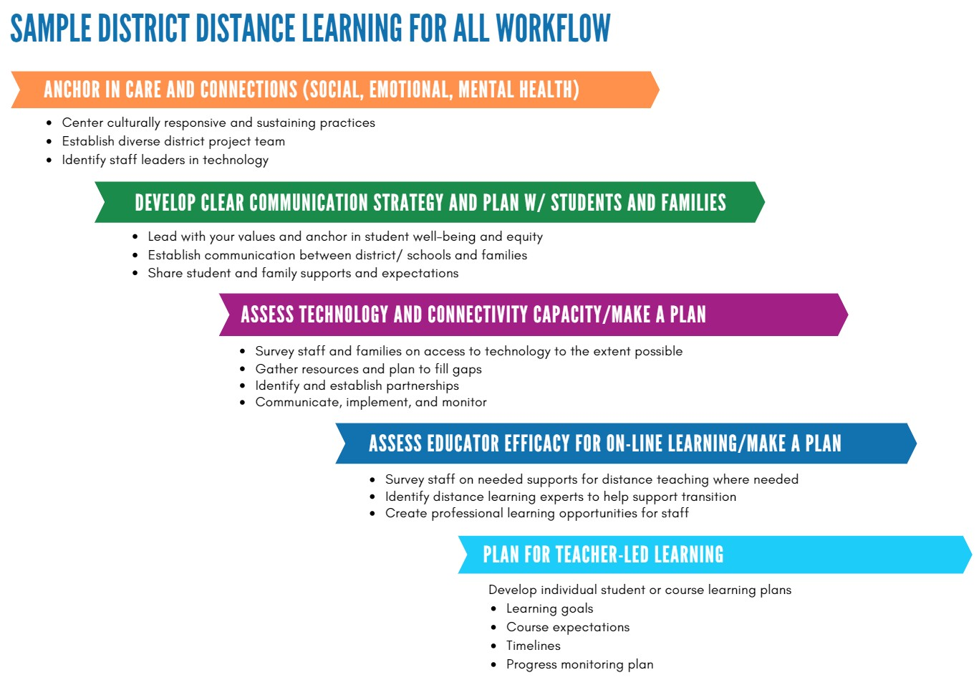

Timeline

Pacing Guide  Required start date for all districts  April 13, 2020 | High Level Action | Cross Walk to Planning Tool
Week 1 (March 30 - April 3) | Anchor in Care and Connection Engage District Planning Team Communicate Internally/Externally | Stage 1  Stage 1  Stage 1
Week 2 (April 6 - April 10) | Gather and Distribute Resources Provide Professional Learning  Communicate Internally/Externally | Stage 1  Stage 2  Stage 2
Week 3 (April 13* - April 17)  *required implementation date | GO LIVE WEEK  Launch Distance Learning for All Communicate Internally/Externally | Stage 3  Stage 3
Week 4 (April 20 - April 24) | Identify gaps  Prioritize needed support Communicate Internally/Externally | Stage 3+  Stage 3+  Stage 3+
Week 5 (April 27 - May 1) | Systematize routine  Create “Plan/Study/Do” Cycle Communicate Internally/Externally | Stage 3+  Stage 3+  Stage 3+

Planning Checklist

Stage 1: Week One

Key Focus: Engage
- Center team and staff around care and connection
- Engage Parents and Families, Local School Board, Community Partners- Do this to the best of your ability, keeping social distancing efforts in place.
- Establish a diverse district project team that may include administrators, special education leadership,
emerging bilingual/EL leadership, IT, teacher leaders, HR, and additional school staff such as counselors, social workers, support staff, translators, community liaisons, Federal Programs/Title Specialists, and Tribal Attendance Promising Practices (TAPP) liaisons. This will look different in district based on district size and personnel.

Key Focus: Plan
- Review Distance Learning for All Guidance with district project team
  - Self assess using the Distance Learning Capacity Framework
  - Review the Sample Distance Learning District Workflow
  - Review the General Timeline for Distance Learning Implementation
  - See Distance Learning Sample Instructional Day (Tool #5)
  - Review Oregon Open Learning and Distance Learning for All: Family and Educator Resources Survey all staff
  - Access to technology
  - Availability
  - Supports needed for materials and instruction
  - Need to access building to pick up materials
  - Best communication methods
Survey families about access to technology and educational resources
  - Preferred method and preferred language for communication
  - Access to technology devices and internet connectivity
  - Availability of learning supplies
  - Availability of transportation to food/curriculum pick-up spots
  - Surveys should be translated to meet families’ linguistic strengths
  - Consider phone outreach for surveys not completed
- Identify district learning platforms, curriculum and existing print materials already in place for teachers to utilize to support instruction

- Identify teacher leaders in curriculum and technology integration, including those who work with specialized populations, to lead professional learning and to serve on planning teams
- Identify resources that can be used in new ways, such as using school buses to deliver instructional
materials
- Identify critical barriers and problem solve, creatively leveraging social and human capital
- Review and update applicable district policies and privacy policies dictating communication between staff and students and distribution of district materials (i.e. Chromebooks, etc.)
- Review Survey Results and Apply to Plan
- Connect with similarly-resourced districts to create support networks (e.g., through ESD Partners or by contacting colleagues) and to share and co-create resources.

Key Focus: Communicate
- Send initial communication to families and staff before the end of week one. Anchor in care and connection. Share any local celebrations and gratitude (i.e. celebrate food service plans and meal providers), provide the information that you know now and provide a general timeline.
  - Use as many modes as possible for communication (hard-copy letters, social media, robocalls,
translated for families as needed).
Stage 2: Week One through Week Three
- Continue and complete any tasks for Week 1 Communication To Students, Families and Community Key Focus: Engage
- Lead with your values and key messages; anchor in student well-being and equity
- Connect with staff around well-being, pace of change and flexibility
- Connect with other districts to share resources

Key Focus: Plan
- Create professional learning opportunities for staff
- Design schedules and consider flexible staffing needs
- Develop building-level plans to reach specialized populations including students experiencing homelessness, students of color and Alaskan Native/American Indian students, emerging bilingual students, students of migrant and farmworker families, students experiencing disability, students in foster care, and students navigating poverty
- Review staff survey results in order to establish best communication methods for staff: consider daily or
frequent messaging to staff from administration, provide talking points and scripts to educators
- Identify and establish partnerships to promote Distance Learning for All

- Consider setting up a tech support desk for parent/student access
- Educators review Oregon Open Learning and Distance Learning for All: Family and Educator Resources and plan for launching Distance Learning for All.

Key Focus: Communicate To Schools and Staff
  - District administration communicates vision, clarifies expectations, and establishes timelines
    - Start with Student Connection - Include a timeline for each school to plan for students to receive at least one contact from school staff (email class-wide message, phone calls, mail, etc.)
    - Schedule and hold building-level or cross-district grade level/content area small group
meetings with elementary, middle, and high school leaders - do these as virtual meetings or conference calls to ensure social distancing practices
    - School administrators hold virtual staff meeting: assign notetaker to send notes to staff for
those who may not be able to attend
    - Connect with staff: encourage staff connectivity, support, and care
    - Share district messaging and expectations for staff
    - Share schedule and resources for professional learning and online tutorials
    - Encourage Professional Learning Communities and Learning Networks
    - Leverage provided resources - ODE COVID-19 webpage, ODE’s Distance Learning for All: Family and Educator Resources, and Oregon Open Learning (OER)

To School Communities and Students/Families
- School building administrators share information with their school communities that includes key district messages as well as school-specific guidance such as the school plan, where to pick up meals, when to expect communication from teachers, how students can pick up or access materials/technology, and how to set up for connectivity
- Share timelines and next steps (phases); Share that communication will be coming out in phases/stages -
ask for patience and feedback
- If available - include distribution of materials plan (devices, hot spots, packets, materials)
- Share guidance for at-home learning schedules (see ODE Tool #5 for Instructional Time)
- Provide updates and guidance for seniors (high schools)
- Include ways for all families to contact district/school with questions/concerns
- Share tutorials for any online learning platforms that will be used to access district curriculum and teacher connection

Stage 3: Implement and Improve Plan (Week 3 and Beyond)

- Continue and complete any tasks for Stage 1 and 2

Key Focus: Engage
- Check in on care and connection of staff
- Check in with key stakeholders (families, educators, partners)
- Progress monitor, focusing on equity, access, and critical gaps. Make needed adjustments.
- Connect educators in learning networks to refine distance learning practices with a focus on equity

Key Focus: Plan
- Principals plan to provide daily updates to building staff on health and safety circumstances and available resources; and define distance learning plans (with back-up plans in the event of staff illness)
- Establish guidelines for tracking student progress
- Educators Develop individual student or course learning plans
  - Learning goals
  - Course expectations
  - Timelines
  - Progress monitoring plan
- Review and revise distance learning plans

Key Focus: Communicate
- Develop a plan for weekly communication with students and families (log contacts and enlist support for any identified barriers to contacting students; identify students who have not been reached and prioritize those families)
- Communicate with seniors and families on student graduation plans (high schools)
- Continue to communicate with and engage stakeholders

Guidance for future planning and sample district plans will be shared by ODE in future communications.

Distance Learning for All—The Pinehurst Way

We are in a unique situation with remote learning. Schools across the nation are interpreting directions to provide equitable learning opportunities while each home situation is different. Our goal at Pinehurst is to strike a balance between providing structure for continued growth and learning and ensuring that expectations are reasonable for parents and students to achieve at home during these strange and often stressful times.

We will provide daily packets and online resources for the core subjects, English Language Arts and Math. We ask that completed work be submitted so we can assess student learning and provide necessary feedback. These are not graded in the traditional sense. They are assessed so we can measure student growth and adjust our teaching accordingly to keep students learning and pushing forward.

For secondary core subjects like Social Studies and Science, we will provide weekly lessons as we see we can reasonably add them without overburdening parents and students at home.

For electives like P.E., Art, Music, Spanish, and Exploration Academy (hands-on science), we will provide optional resources for you and the students to choose from. We will not be requiring or assessing these. We just highly recommend that you try to include them in your learning plan at home. There are some incredible opportunities that have popped up during these times- let's take advantage of them!

Remote learning attendance will be tracked by your student’s participation in meeting with their teacher remotely and completing assigned core subject work.

Both teachers are providing “Office Hours” daily so that you know when you can best reach us for answers to student questions about any of the assignments or to conference more generally.

We are using Remind, Google Classroom, Zoom, Facetime and email to communicate with students, parents, staff, school board, ESD, Jackson County Health Department and ODE about Covid-19 updates, District Learning for All guidance and daily assignments. We are using an outdoor drop box system for students to pick up learning packets and drop off completed assignments.

The staff is working together to make sure that every Pinehurst student has equal opportunity to engage in learning during the school closure. Currently every student has an iPad, laptop or computer at home that they can use to access online materials. Free Wifi, in the Annex, is available by appointment only for any student that has unreliable internet at home.

