Fall in the Field

Greensprings Mountain Loop Field Trip

Tuesday, Sep. 12, 2023

Dear Parents,

On Tuesday, September 12th Pinehurst students will participate in an SOU Environmental Education graduate program called Fall in the Field. Our students will be hiking the Greensprings Mountain Loop trail with an environment ed grad student. Students will learn about the flora and fauna as well as the ecology and natural environment of our very own Cascade Siskiyou National Monument.

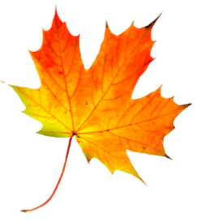The itinerary will be as follows:

8:15 Arrive at school.

9:00 Leave Pinehurst

9:30 Arrive at Greensprings Mountain Loop trailhead. Students use restrooms and eat snack.

10:00 Lesson and hike to lunch spot

11:15 Lunch

11:45 Lesson while hiking back to trailhead.

1:15 Wrap-up, Good-byes then head back to Pinehurst.

2:45 Regular dismissal

**Please read, sign, and return the following 3 items (the yellow pages) by this Friday, September 8th.**

1. Permission slip/ Liability Form
2. Photo/ Video Release Form
3. Health History Form

Also included in this packet is a packing list for the trip. Please let your child’s teacher know right away if you cannot get all the items on this list so that we can help you find resources for getting them.